# Who are we and what do we do?



**Breck Foundation**

**is coming to your school...**

We are a Southeast England-based charity with national relevance and impact, founded in 2014 in response to the tragic loss of Breck Bednar, a 14-year-old boy who was groomed and murdered by someone he met online. Our work aims to prevent this from ever happening again.

We reach thousands of children and young people in schools and other community settings with Breck's story every year. Our talks and educational materials fill a gap in the current UK curriculum that otherwise leaves children vulnerable to online grooming and exploitation.

# What will your child learn?

We deliver educational sessions in schools for children from the age of 5 up to 18, but also for parents, teachers, governors and all school staff. Using Breck's story, we deliver powerful, compelling online safety presentations to educate everyone on the dangers that children and young people face online from grooming, exploitation and abuse, as well as from exposure to inappropriate or harmful content.

To find out more about our sessions please see our website: [www.breckfoundation.org/speaker-sessions](http://www.breckfoundation.org/speaker-sessions)

# FAQs

*What should I do if I have concerns about the content of the presentation?*

We make sure that the content of our talks is age-appropriate, but if you have any concerns, please contact the school staff member organising this event.

*What should I do after the presentation?*

* Speak to your child about what they thought of the presentation.
* Ask if they have any concerns about the subject.
* Reassure your child they can talk to you about any concerns relating to online behaviour.
* Remind them to look out for their friends too.

Your school will be provided with post-presentation packs for parents that they can send on, if they do not do so, please remind them!

# Primary School



**Breck Foundation:**

**What's included in the session?**

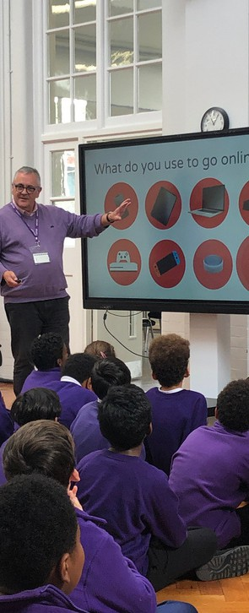We deliver age-appropriate sessions in schools for children and young people. We usually deliver our sessions to two year groups at a time. These sessions are designed specifically to highlight online safety, security and signposting to help in an accessible way.

**Sessions for each age grouping include:**

**Years 1-2:**

The session is approximately 40 minutes long and focuses on online safety tips, including how to stay safe and what to do if they encounter bad behaviour online.

**Y3-4: (school to delete as appropriate)**

The session is approximately 45 minutes long and focuses on online safety tips including how to stay safe and what to do if they encounter bad behaviour online, in this age group we also touch upon catfishing and grooming.

**OR**

Breck’s story (see information below)

**Years 5-6:**

The session is approximately 1 hour long and includes:

* Breck’s story (told in an age-appropriate and sensitive way)  Gaming and social media
* What is grooming?
* Learning the signs of grooming and how to spot them
* Speaking up and reporting – including who to talk to when reporting online danger
* Where to find help - this can be customised to the school in question to include the services or specialists a school may have

**included in the session?**



**Breck Foundation: What's**

# Secondary School

In our secondary school sessions, our content is tailored to be age appropriate for the different year groups we are presenting too. We typically present to two year groups at a time with hour-long sessions, including space for questions.

These sessions include detailed references to Breck’s story, information on staying safe whilst gaming, how to spot grooming on social media as well as more focused information on online grooming, such as:

* Learning the signs of grooming
* Speaking up and reporting (including, how to tell someone you think you've found a groomer or are being groomed)
* Where to find help (this can be customised to a school’s specific services/specialists and signposts teachers and parents)

We also include references to:

* County lines
* Radicalisation
* Gang recruitment
* Sharing nude pictures

These are all types of grooming young people may come across as digital natives. We often customise the information that we share in our presentations for different schools, especially if a school is facing a particular problem that they would like highlighted.

**Brecks Last Game:** Secondary school students also watch our film, Breck’s Last Game. This is officially rated a 15 certificate for cinematic use. However, within an educational setting and with the correct facilitation from a Breck Foundation Speaker the film is widely seen as a valuable educational tool.

We always abide by the discretion of [individual schools as to whether it would be suita](https://www.youtube.com/watch?v=U_fExISISv4)ble for their students - the link to this film is here: <https://www.youtube.com/watch?v=U_fExISISv44>

**Parent session from Breck Foundation**

**There has been an 82% increase in online grooming crimes over the last four years. - in 2022 there were over 60.000 cases of children being groomed into creating sexual imagery.** This is a growing problem that we cannot ignore.

**9 out of 10 young people** say they would act differently online after having a Breck Foundation workshop -which means every young person we can reach is potentially another saved from experiencing life-changing online abuse•.

By attending a parent talk you can understand what we taught your children and the ways you can support them to stay safe. Nothing is more important to us than the safety of your children.

|  |
| --- |
| Your Breck Foundation Session:  Date:  Time:  Zoom Link:  Password: |

*Really interesting to hear how Lewis isolated Breck from his friends* & to *hear the way Breck seemed to accept his parents' concerns. but in reality, he was* still *in contact* & *passing on information* to Lewis. *A very eye-opening account of what happened.*

*Parent feedback* - *St. Cuthbert's Catholic Primary School* - *2023*

**Parent and carer talks are a great opportunity to highlight the importance of communication with our children about the dangers they face online every day.** This ultimately increases the family’s wellbeing by opening lines of communication.

**These sessions include:**

* Breck's story - a real-life story of what could happen to your child.
* Who or what is an online groomer and what are the types of grooming your child may be exposed to?
* How to have that awkward parent-child conversation, gaining trust and sharing your concerns about online safety.
* Where to find and how to get help if your child is facing online abuse
* A showing of Breck's Last Game - which you can then share with your children to start conversations and keep them safe.

Each session also makes reference to what your children have learnt or will learn from our sessions. So that you as parents can talk to them about it and make sure they stick to healthy habits that keep them safe.

The **Breck** Foundation Hatton Garden. Holbom. London, EC1rN8DX Registered charity number: l168384